A Mini Project Report On

PROFILE SWAPPER
(FOR ANDROID MOBILES)

Submitted in Partial fulfillment of the requirements for the award of the degree of

BACHELOR OF TECHNOLOGY

In

COMPUTER SCIENCE AND ENGINEERING

Under the Guidance of

Mr. Vikranth
Assistant Professor

BY
Y. Shravani(11D21A0593)
P. Sirisha Rani(11D21A0595)
J. Tejaswi(11D21A05B5)



Department Of Computer Science and Engineering
SRIDEVI WOMEN’S ENGINEERING COLLEGE
(Approved by AICTE and affiliated to JNTU. HYD)
2013-2014

Department Of Computer Science and Engineering
SRIDEVI WOMEN’S ENGINEERING COLLEGE
(Approved by AICTE and affiliated to JNTU. HYD)

2013-2014

CERTIFICATE

This is to certify that the Mini Project report entitled “PROFILE SWAPPER ( for Android Mobiles )” is being submitted by Y.Shravani (H.T.No.11D21A0593), P.Sirisha Rani (H.T.No.11D21A0595), J.Tejaswi (H.T.No.11D21A05B5) in partial fulfillment for the award of degree of Bachelor of Technology in Computer Science and Engineering is a record of bonafide work carried out by them.

Internal Guide Coordinator H.O.D.
Mr. Vikranth Mr.L.Abdul Saleem Dr.Anitha.P
Assistant Professor Assistant Professor Professor

DECLARATION

I hereby declare that the mini project entitled “PROFILE SWAPPER (for Android Mobiles)” using Android is the work done during the period from 1st June 2014 to 30th June 2014 and is submitted in partial fulfillment of the requirements for the award of degree of Bachelor of Technology in Computer Science and Engineering from Jawaharlal Nehru Technological University, Hyderabad.

Y. Shravani(11D21A93),
P. Sirisha Rani(11D21A055),
J. Tejaswi(11D21A05B5).

ACKNOWLEDGEMENT

There are many people who helped us directly and indirectly to complete my mini project successfully. We would like to take this opportunity to thank one and all.

First of all I would like to express my deep gratitude towards my internal guide Mr.Vikranth, Assistant Professor, Dept of CSE for his support in completion of our dissertation. I wish to express my sincere thanks to Dr. Anitha.P, HOD, Dept of CSE and also to my principal Dr.B.L.MALLESWARI for providing the facilities to complete the dissertation.

We would like to thank all my faculty and friends for their help and constructive criticism during my project period. Finally I am very much indebted to my parents for their moral support and encouragement to achieve goals.

Y. Shravani(11D21A93),
P. Sirisha Rani(11D21A055),
J. Tejaswi(11D21A05B5).

ABSTRACT

In real life, forgetting the things is a very common tendency by humans. Few times, we may keep the things in our premises and we may forget about it. Same thing may happen with our mobiles phones too. We may forget/lose our phone in our near premises. We may think that, we can just make call to that phone and find the location. Where in few cases you may want to set your phone mode to silent when you are at some work and your phone isn’t near you, but you still might want to turn it to silent. But if the phone is in silent mode what can we do to our mobile and how can we change its profile? In these situations, this project is very helpful. In this project, just by sending a single customized message to our phone we change our phone mode to ringing or silent or vibrate or flight profile.

INDEX

CONTENTS PAGE NO

- Introduction

1.1 Problem Definition 3
1.2 Existing System 3
1.3 Proposed System 3
1.3.1 Modules 4
1.4 Scope of Project 4

- Literature Survey

2.1 Java 5
2.2 Android 7
2.2.1 About Native code 9
2.2.2 Creating an android project 9
2.2.3 To create an AVD with the AVD manager 10
2.2.4 To Create or Modify a Launch Configuration 11

2.3 SQ Lite
2.3.1 Design 11
2.3.2 Features 22

- System Analysis

3.1 Software Requirements 23
3.2 Hardware Requirements 23

3.3 Feasibility Study 23

3.3.1 Economic Feasibility 23
3.3.2 Operational Feasibility 23
3.3.3 Technical Feasibility 23

- System Design

4.1 Architecture Diagram 25
4.2 Data Flow Diagrams 25
4.2.1 DFD Symbols 26
4.3 Unified Modeling Language (UML) 26

- System Coding and Implementation

5.1 Implementation 43
  - Coding 43
  - Screen Shots 50

- Testing and Validation
6.1 Unit Testing 52
6.2 Integration Testing 52
6.3 Validation Testing 52
6.4 System Testing 52

- Conclusion & future enhancements
7.1 Conclusions 53
7.2 Future Enhancement 53

- References 54

LIST OF FIGURES

FIG.NO FIG.NAME PAGE.NO

4.1 Sequence diagram for code 34
4.2 Sequence diagram for mode 35
4.3 Use case diagram 37
4.4 Class diagram 40
4.5 Object Diagram 41
4.6 State chart diagram 42
4.7 Deployment diagram 43
5.3.1 Start up screen 51
5.3.2 Code screen 52

1. INTRODUCTION

1.1 PROBLEM DEFINITION
One of the fastest growing industries now a days is mobile industry. There are many competitors in this area who are doing research and development on new platforms & user’s experience. One such technology is Android from Google which is supported for many manufactured phones. These phones are described as next Generation mobiles. In real life, forgetting the things is very common human tendency. Sometimes, we may kept the things in our premises and we may forget about it. Same thing may happen with our mobiles too. We may forget/lose our phone in our near premises. We may think that, we can just make call to that phone and find the location. Where in few cases you But if the phone is in silent mode what we can do? how can we find the mobile location?

In that situation this project is very helpful. In this project, just by sending a single message to our phone we are changing our phone mode to ringing or silent or vibrate whatever we want. This application supports 2.3 version of android frame work.

1.2 EXISTING SYSTEM
There are few applications which only changes the mode of a mobile when lost in the silent state, to the ring state. But, the reverse is not possible.

1.3 PROPOSED SYSTEM
To overcome the drawback in the existing System we are going to develop this project.

Advantages
- Giving the security codes for each mode(silent,Ring,Vibrate)
- Using that security code, changing our phone mode to silent,ring or vibrate.

1.3.1 Modules
Profile Swapper on android is having the following modules
- Setting the security code
- Changing the phone mode
1.Setting the security code:
In this module,we need to set security code for each mode i.e. silent,ring and vibrate. By default values will be silent for silent mode,ring for Ring mode and vibrate for vibrate mode. User can also change these values.
2.Changing the phone mode:
Whatever the codes you have given, just send that code as a message to your phone. Then your phone will be changed to that particular mode what u have sent.

1.4 SCOPE OF PROJECT
One of the fastest growing industries is mobile industry. There are many competitors in this area who are doing research and development on new platforms & user experience. One such technology is Android from Google which is supported for Google phones. These phones are described as next Generation mobiles [As described by Google]. Developing application for such mobile phones using the open source android SDK is quite interesting. This makes the application call history quite easy, efficient, flexible and economic

2.LITERATURE SURVEY

2.1 JAVA
Java is an object-oriented language, and is very similar to C++. Java is simplified to eliminate language features that cause common programming errors. Java source code files are compiled into a format called byte code, which can then be executed by a Java interpreter. Features are
- Platform Independent
The programs written on one platform can run on any platform provided the platform must have the JVM.
- Portable
The feature Write-once-run-anywhere makes the java language portable provided that the system must have interpreter for the JVM.
- Simple
Programs are easy to write and debug because java does not use the pointers explicitly. It also has the automatic memory allocation and de-allocation system.
- Multi threaded
Multithreading means a single program having different threads executing independently at the same time.
- Robust
Java has the strong memory allocation and automatic garbage collection mechanism. It provides the powerful exception handling and type checking mechanism as compare to other programming languages.

- Object Oriented
To be an Object Oriented language, any language must follow at least the four characteristics.
- Inheritance
- Encapsulation
- Polymorphism
- Dynamic binding
- Distributed
The widely used protocols like HTTP and FTP are developed in java. Internet programmers can call functions on these protocols and can get access to the files from any remote machine on the internet rather than writing codes on their local system.
- Secure
All the programs in java are run under an area known as the sand box. Security manager determines the accessibility options of a class like reading and writing a file to the local disk.
- High Performance
In the beginning interpretation of byte code resulted in slow performance but the advance version of JVM uses the adaptive and just in time compilation technique that improves the performance.
- Integrated
Java is an interpreted language as well. Programs run directly from the source code.

2.2 ANDROID
Android is a software stack for mobile devices that includes an operating system, middle ware and key applications. The android SDK provides the tools and APIs necessary to begin developing applications on the Android platform using the Java programming language.

Features
- Application framework enabling reuse and replacement of components.
- Dalvik virtual machine optimized for mobile devices.
- Integrated browser based on the open source WebKit engine.
- Optimized graphics powered by a custom 2D graphics library; 3D graphics based on the OpenGL ES 1.0 specification (hardware acceleration optional)
- SQLite for structured data storage
- Media support for common audio, video, and still image formats (MPEG4, H.264, MP3, AAC, AMR, JPG, PNG, GIF)
- GSM Telephony (hardware dependent)

Android application
Developers have full access to the same framework APIs used by the core applications. The application architecture is designed to simplify the reuse of components; any application can publish its capabilities and any other application may then make use of those capabilities (subject to security constraints enforced by the framework). This same mechanism allows components to be replaced by the user.

Libraries
Android includes a set of C/C++ libraries used by various components of the Android system. These capabilities are exposed to developers through the Android application framework. Some of the core libraries are listed below
- System C library - a BSD-derived implementation of the standard C system library (libc), tuned for embedded Linux-based devices
- Media Libraries - based on Packet Video's Open CORE; the libraries support playback and recording of many popular audio and video formats, as well as static image files, including MPEG4, H.264, MP3, AAC, AMR, JPG, and PNG
- Surface Manager - manages access to the display subsystem and seamlessly composites 2D and 3D graphic layers from multiple applications
- LibWebCore - a modern web browser engine which powers both the Android browser and an embeddable web view
- SGL - the underlying 2D graphics engine
- 3D libraries - an implementation based on OpenGL ES 1.0 APIs; the libraries use either hardware 3D acceleration (where available) or the included, highly optimized 3D software rasterizer
- FreeType - bitmap and vector font rendering
- SQLite - a powerful and lightweight relational database engine available to all applications

Android Runtime
Android includes a set of core libraries that provides most of the functionality available in the core libraries of the Java programming language.
Every Android application runs in its own process, with its own instance of the Dalvik virtual machine. Dalvik has been written so that a device can run multiple VMs efficiently. The Dalvik VM executes files in the Dalvik Executable format which is optimized for minimal memory footprint. The VM is register-based, and runs classes compiled by a Java language compiler that have been transformed into the .dex format by the included "dx" tool.
Developing in eclipse with ADT:
The Android Development Tools (ADT) plugin for Eclipse adds powerful extensions to the Eclipse integrated development environment. It allows you to create and debug Android applications easier and faster. If you use Eclipse, the ADT plugin gives you an incredible boost in developing Android applications:
It gives you access to other Android development tools from inside the Eclipse IDE. For example, ADT lets you access the many capabilities of the DDMS tool: take screen shots, manage port-forwarding, set breakpoints, and view thread and process information directly from Eclipse.
The Android SDK includes a comprehensive set of development tools. These include a debugger, libraries, a handset emulator (based on QEMU), documentation, sample code, and tutorials. Currently supported development platforms include x86-architecture computers running Linux (any modern desktop Linux distribution), Mac OS X 10.4.8 or later, Windows XP or Vista. The officially supported integrated development environment (IDE) is Eclipse (3.2 or later) using the Android Development Tools (ADT) Plug in, though developers may use any text editor to edit Java and XML files then use command line tools to create, build and debug Android application
2.2.1 About Native code:
Libraries written in C and other languages can be compiled to ARM native code and installed, but the Native Development Kit is not yet officially supported by Google. Native classes can be called from Java code running under the Dalvik VM using the System. Load Library call, which is part of the standard Android Java classes.
2.2.2 Creating an android project:
The ADT plug-in provides a New Project Wizard that you can use to quickly create a new Android project (or a project from existing code). To create a new project:
- Select File > New > Project.
- Select Android > Android Project, and click Next.
- Select the contents for the project:
- Enter a Project Name. This will be the name of the folder where your project is created.
- Under Contents, select Create new project in workspace. Select your project workspace location.
- Under Target, select an Android target to be used as the project's Build Target. The Build Target specifies which Android platform you'd like your application built against.
- Unless you know that you'll be using new APIs introduced in the latest SDK, you should select a target with the lowest platform version possible, such as Android 1.1.
- Under Properties, fill in all necessary fields :
Enter an Application name. This is the human-readable title for your application — the name that will appear on the Android device.
- Enter a Package name. This is the package namespace where all your source code will reside.
- Select Create Activity and enter a name for your main Activity class.
- Enter a Min SDK Version. This is an integer that indicates the minimum API Level required to properly run your application. Entering this here automatically sets the min SDK Version attribute in the <uses-sdk> of your Android Manifest file. If you're unsure of the appropriate API Level to use, copy the API Level listed for the Build Target you selected in the Target tab.
4. Click Finish.
2.2.3 To create an AVD with the AVD manager
- Select Window > Android SDK and AVD Manager, or click the Android SDK and AVD Manager icon (a black device) in the Eclipse toolbar.
- In the Virtual Devices panel, you'll see a list of existing AVDs. Click New to create a new AVD.
- Fill in the details for the AVD.
- Give it a name, a platform target, an SD card image (optional), and a skin (HVGA is default).
- Click Create AVD.
When you first run a project as an Android Application, ADT will automatically create a run configuration. The default run configuration will launch the default project Activity and use automatic target mode for device selection (with no preferred AVD).
2.2.4 To Create or Modify a Launch Configuration
Follow these steps as appropriate for your Eclipse version:
- Open the run configuration manager.
- In Eclipse 3.3, select Run > Open Run Dialog
- In Eclipse 3.4, select Run > Run Configurations
- Expand the Android Application item and create a new configuration or open an existing one.
2.3 SQLITE
SQLite is an ACID-compliant embedded relational database management system contained in a relatively small C programming library. The source code for SQLite is in the public domain.
2.3.1 Design Unlike client-server database management systems, the SQLite engine is not a standalone process with which the application program communicates. Instead, the SQLite library is linked in and thus becomes an integral part of the application program. The library can also be called dynamically. The application program uses SQLite's functionality through simple function calls, which reduces latency in database access as function calls within a single process are more efficient than inter-process communication.
An Android application should be fast. Well, it's probably more accurate to say that it should be efficient. That is, it should execute as efficiently as possible in the mobile device environment, with its limited computing power and data storage, smaller screen, and constrained battery life.
Introduction
There are two basic rules for resource-constrained systems
- Don't do work that you don't need to do.
- Don't allocate memory if you can avoid it.
All the tips below follow from these two basic tenets.
Some would argue that much of the advice on this page amounts to "premature optimization." While it's true that micro-optimizations sometimes make it harder to develop efficient data structures and algorithms, on embedded devices like handsets you often simply have no choice. For instance, if you bring your assumptions about VM performance on desktop machines to Android, you're quite likely to write code that exhausts system memory. This will bring your application to a crawl — let alone what it will do to other programs running on the system!
That's why these guidelines are important. Android's success depends on the user experience that your applications provide, and that user experience depends in part on whether your code is responsive and snappy, or slow and aggravating. Since all our applications will run on the same devices, we're all in this together, in a way. Think of this document as like the rules of the road you had to learn when you got your driver's license: things run smoothly when everybody follows them, but when you don't, you get your car smashed up.
Avoid creating objects:
Object creation is never free. A generational GC with per-thread allocation pools for temporary objects can make allocation cheaper, but allocating memory is always more expensive than not allocating memory.
If you allocate objects in a user interface loop, you will force a periodic garbage collection, creating little "hiccups" in the user experience. Thus, you should avoid creating object instances you don't need to. Some examples of things that can help:
When extracting strings from a set of input data, try to return a substring of the original data, instead of creating a copy. You will create a new String object, but it will share the char[] with the data.
An array of ints is a much better than an array of Integers, but this also generalizes to the fact that two parallel arrays of ints are also a lot more efficient than an array of (int,int) objects. The same goes for any combination of primitive types. If you need to implement a container that stores tuples of (Foo,Bar) objects, try to remember that two parallel Foo[] and Bar[] arrays are generally much better than a single array of custom (Foo,Bar) objects.
Generally speaking, avoid creating short-term temporary objects if you can. Fewer objects created mean less-frequent garbage collection, which has a direct impact on user experience.
Use native methods:
When processing strings, don't hesitate to use specialty methods like String.indexOf(), String.lastIndexOf(), and their cousins. These are typically implemented in C/C++ code that easily runs 10-100x faster than doing the same thing in a Java loop.
The flip side of that advice is that punching through to a native method is more expensive than calling an interpreted method. Don't use native methods for trivial computation, if you can avoid it.
Prefer Virtual Over Interface:
Suppose you have a HashMap object. You can declare it as a HashMap or as a generic Map:
Map myMap1 = new HashMap();
HashMap myMap2 = new HashMap();
Which is better?
Conventional wisdom says that you should prefer Map, because it allows you to change the underlying implementation to anything that implements the Map interface. Conventional wisdom is correct for conventional programming, but isn't so great for embedded systems. Calling through an interface reference can take 2x longer than a virtual method call through a concrete reference.
If you have chosen a HashMap because it fits what you're doing, there is little value in calling it a Map. Given the availability of IDEs that refactor your code for you, there's not much value in calling it a Map even if you're not sure where the code is headed.
Prefer static over virtual:
If you don't need to access an object's fields, make your method static. It can be called faster, because it doesn't require a virtual method table indirection. It's also good practice, because you can tell from the method signature that calling the method can't alter the object's state.
Avoid internal getters/setters:
In native languages like C++ it's common practice to use getters (e.g. i = getCount()) instead of accessing the field directly (i = mCount). This is an excellent habit for C++, because the compiler can usually inline the access, and if you need to restrict or debug field access you can add the code at any time.
On Android, this is a bad idea. Virtual method calls are expensive, much more so than instance field lookups. It's reasonable to follow common object-oriented programming practices and have getters and setters in the public interface, but within a class you should always access fields directly.
Declare Constants Final:
Consider the following declaration at the top of a class:
static int intVal = 42;
static String strVal = "Hello, world!";
The compiler generates a class initializer method, called <clinit>, that is executed when the class is first used. The method stores the value 42 into intVal, and extracts a reference from the classfile string constant table for strVal. When these values are referenced later on, they are accessed with field lookups.
We can improve matters with the "final" keyword:
static final int intVal = 42;
static final String strVal = "Hello, world!";
The class no longer requires a <clinit> method, because the constants go into classfile static field initializes, which are handled directly by the VM. Code accessing intVal will use the integer value 42 directly, and accesses to strVal will use a relatively inexpensive "string constant" instruction instead of a field lookup.
Declaring a method or class "final" does not confer any immediate performance benefits, but it does allow certain optimizations. For example, if the compiler knows that a "getter" method can't be overridden by a sub-class, it can inline the method call.
You can also declare local variables final. However, this has no definitive performance benefits. For local variables, only use "final" if it makes the code clearer.
Designing For Responsiveness
It's possible to write code that wins every performance test in the world, but still sends users in a fiery rage when they try to use the application. These are the applications that aren't responsive enough — the ones that feel sluggish, hang or freeze for significant periods, or take too long to process input.
In Android, the system guards against applications that are insufficiently responsive for a period of time by displaying a dialog to the user, called the Application Not Responding (ANR) dialog. The user can choose to let the application continue, but the user won't appreciate having to act on this dialog every time he or she uses your application. So it's important to design responsiveness into your application, so that the system never has cause to display an ANR to the user.
Generally, the system displays an ANR if an application cannot respond to user input. For example, if an application blocks on some I/O operation (frequently a network access), then the main application thread won't be able to process incoming user input events. After a time, the system concludes that the application has hung, and displays the ANR to give the user the option to kill it.
Similarly, if your application spends too much time building an elaborate in-memory structure, or perhaps computing the next move in a game, the system will conclude that your application has hung. It's always important to make sure these computations are efficient using the techniques above, but even the most efficient code still takes time to run.
What Triggers ANR:
In Android, application responsiveness is monitored by the Activity Manager and Window Manager System services. Android will display the ANR dialog for a particular application when it detects one of the following conditions:
- No response to an input event within 5 seconds.
- A Broadcast Receiver hasn't finished executing within 10 seconds
How to Avoid ANR:
Given the above definition for ANR, let's examine why this can occur in Android applications and how best to structure your application to avoid ANR.
Android applications normally run entirely on a single (i.e. main) thread. This means that anything your application is doing in the main thread that takes a long time to complete can trigger the ANR dialog because your application is not giving itself a chance to handle the input event or Intent broadcast.
Therefore any method that runs in the main thread should do as little work as possible. In particular, Activities should do as little as possible to set up in key life-cycle methods such as on Create () and on Resume (). Potentially long running operations such as network or database operations, or computationally expensive calculations such as resizing bitmaps should be done in a child thread (or in the case of databases operations, via an asynchronous request). However, this does not mean that your main thread should block while waiting for the child thread to complete — nor should you call Thread. Wait () or Thread. Sleep (). Instead of blocking while waiting for a child thread to complete, your main thread should provide a Handler for child threads to post back to upon completion. Designing your application in this way will allow your main thread to remain responsive to input and thus avoid ANR dialogs caused by the 5 second input event timeout. These same practices should be followed for any other threads that display UI, as they are also subject to the same timeouts.
Reinforcing Responsiveness:
Generally, 100 to 200ms is the threshold beyond which users will perceive lag (or lack of "snappiness," if you will) in an application. As such, here are some additional tips beyond what you should do to avoid ANR that will help make your application seem responsive to users.
If your application is doing work in the background in response to user input, show that progress is being made. For games specifically, do calculations for moves in a child thread.
If your application has a time-consuming initial setup phase, consider showing a splash screen or rendering the main view as quickly as possible and filling in the information asynchronously. In either case, you should indicate somehow that progress is being made, lest the user perceive that the application is frozen.
Designing for Seamlessness:
Even if your application is fast and responsive, certain design decisions can still cause problems for users — because of unplanned interactions with other applications or dialogs, inadvertent loss of data, unintended blocking, and so on. To avoid these problems, it helps to understand the context in which your applications run and the system interactions that can affect your application. In short, you should strive to develop an application that interacts seamlessly with the system and with other applications.
A common seamlessness problem is when an application's background process — for example, a service or broadcast receiver — pops up a dialog in response to some event. This may seem like harmless behavior, especially when you are building and testing your application in isolation, on the emulator. However, when your application is run on an actual device, your application may not have user focus at the time your background process displays the dialog. So it could end up that your application would display it's dialog behind the active application, or it could take focus from the current application and display the dialog in front of whatever the user was doing (such as dialing a phone call, for example). That behavior would not work for your application or for the user.
To avoid these problems, your application should use the proper system facility for notifying the user — the Notification classes. Using notifications, your application can signal the user that an event has taken place, by displaying an icon in the status bar rather than taking focus and interrupting the user.
Another example of a seamlessness problem is when an activity inadvertently loses state or user data because it doesn't correctly implement the on Pause () and other lifecycle methods. Or, if your application exposes data intended to be used by other applications, you should expose it via a Content Provider, rather than (for example) doing so through a world-readable raw file or database.
This document discusses common seamlessness problems and how to avoid them. It covers these topics:
Don’t Drop Data:
Always keep in mind that Android is a mobile platform. It may seem obvious to say it, but it's important to remember that another Activity (such as the "Incoming Phone Call" app) can pop up over your own Activity at any moment. This will fire the onSaveInstanceState () and on Pause() methods, and will likely result in your application being killed.
If the u ser was editing data in your application when the other Activity appeared, your application will likely lose that data when your application is killed. Unless, of course, you save the work in progress first. The "Android Way" is to do just that: Android applications that accept or edit input should override the onSaveInstanceState () method and save their state in some appropriate fashion. When the user revisits the application, she should be able to retrieve her data. A classic example of a good use of this behavior is a mail application. If the user was composing an email when another Activity started up, the application should save the in-process email as a draft.
Don’t Expose Raw Data:
If you wouldn't walk down the street in your underwear, neither should your data. While it's possible to expose certain kinds of application to the world to read, this is usually not the best idea. Exposing raw data requires other applications to understand your data format; if you change that format, you'll break any other applications that aren't similarly updated.
The "Android Way" is to create a Content Provider to expose your data to other applications via a clean, well-thought-out, and maintainable API. Using a Content Provider is much like inserting a Java language interface to split up and componentized two tightly-coupled pieces of code. This means you'll be able to modify the internal format of your data without changing the interface exposed by the Content Provider, and this without affecting other applications.
Don’t Interrupt The User:
If the user is running an application (such as the Phone application during a call) it's a pretty safe bet he did it on purpose. That's why you should avoid spawning activities except in direct response to user input from the current Activity.
That is, don't call start Activity () from Broadcast Receivers or Services running in the background. Doing so will interrupt whatever application is currently running, and result in an annoyed user. Perhaps even worse, your Activity may become a "keystroke bandit" and receive some of the input the user was in the middle of providing to the previous Activity. Depending on what your application does, this could be bad news.
Instead of spawning Activity UIs directly from the background, you should instead use the Notification Manager to set Notifications. These will appear in the status bar, and the user can then click on them at his leisure, to see what your application has to show him.
Go a Lot to Do? Do it in a Thread:
If your application needs to perform some expensive or long-running computation, you should probably move it to a thread. This will prevent the dreaded "Application Not Responding" dialog from being displayed to the user, with the ultimate result being the fiery demise of your application.
By default, all code in an Activity as well as all its Views run in the same thread. This is the same thread that also handles UI events. For example, when the user presses a key, a key-down event is added to the Activity's main thread's queue. The event handler system needs to de-queue and handle that event quickly; if it doesn't, the system concludes after a few seconds that the application is hung and offers to kill it for the user.
Extended system themes:
When it comes to the look-and-feel of the user interface, it's important to blend in nicely. Users are jarred by applications which contrast with the user interface they've come to expect. When designing your UIs, you should try and avoid rolling your own as much as possible. Instead, use a Theme. You can override or extend those parts of the theme that you need to, but at least you're starting from the same UI base as all the other applications. For all the details, read Applying Styles and Themes.

Design your UI to work with multiple screen resolutions:
Different Android-powered devices will support different screen resolutions. Some will even be able to change resolutions on the fly, such as by switching to landscape mode. It's important to make sure your layouts and drawables are flexible enough to display properly on a variety of device screens.
Fortunately, this is very easy to do. In brief, what you must do is provide different versions of your artwork for the key resolutions, and then design your layout to accommodate various dimensions. If you do that much, the system handles the rest, and your application looks great on any device.
Don’t assume touch screen or key board:
Android will support a variety of handset form-factors. That's a fancy way of saying that some Android devices will have full "QWERTY" keyboards, while others will have 40-key, 12-key, or even other key configurations. Similarly, some devices will have touch-screens, but many won't.
When building your applications, keep that in mind. Don't make assumptions about specific keyboard layouts -- unless, of course, you're really interested in restricting your application so that it can only be used on those devices.
Do converse the device battery:
A mobile device isn't very mobile if it's constantly plugged into the wall. Mobile devices are battery-powered, and the longer we can make that battery last on a charge, the happier everyone is — especially the user. Two of the biggest consumers of battery power are the processor, and the radio; that's why it's important to write your applications to do as little work as possible, and use the network as infrequently as possible.
Minimizing the amount of processor time your application uses really comes down to writing efficient code. To minimize the power drain from using the radio, be sure to handle error conditions gracefully, and only fetch what you need. For example, don't constantly retry a network operation if one failed. If it failed once, it's likely because the user has no reception, so it's probably going to fail again if you try right away; all you'll do is waste battery power.
Users are pretty smart: if your program is power-hungry, you can count on them noticing. The only thing you can be sure of at that point is that your program won't stay installed very long.
2.3.2 Features
SQLite implements most of the SQL-92 standard for SQL but it lacks some features. A standalone program called sqlite3 is provided which can be used to create a database, define tables within it, insert and change rows, run queries and manage an SQLite database file. SQLite is a popular choice for local/client SQL storage within a web browser and within a rich internet application framework. This may be because SQLite's dynamically typed storage matches the web browser's core languages of Javascript and XML. SQLite uses an unusual type system for an SQL-compatible DBMS. Instead of assigning a type to a column as in most SQL database systems, types are assigned to individual values; in language terms it is dynamically typed.
3. SYSTEM ANALYSIS
3.1 SOFTWARE REQUIREMENTS
- Java
- Android SDK 1.5 or later
- Eclipse Ganymede IDE
- Operating System can be Windows XP, LINUX and Mac etc.
3.2 HARDWARE REQUIREMENTS
1. PROCESSOR : (min) P4 Pentium
2. RAM : (min) 128
3. HARD DISK : 100 MB

3.3 FEASIBILITY STUDY
An important outcome of the preliminary investigation is the determination that system requested is feasible. This is to identify the objectives of a new system. Before solving a problem one must know what the problem is. The study is carried out by a small group of people who are familiar with system analysis and design process. Fact finding techniques are used to gather the required information.
The three major areas consider while determining the feasibility of the project are
- Economic Feasibility
- Operational Feasibility
3. Technical Feasibility
3.3.1 Economic Feasibility
Economic feasibility attempts to weigh the costs of developing and implementing a new system, against the benefits that would accrue from having the new system in place. This feasibility study gives the top management the economic justification for the new system. A simple economic analysis which gives the actual comparison of costs and benefits are much more meaningful in this case. These could include increased customer satisfaction, improvement in product quality better decision making timeliness of information, expediting activities, improved accuracy of operations, better documentation and record keeping, faster retrieval of information, better employee morale.
3.3.2 Operational Feasibility
Proposed projects are beneficial only if they can be turned into information systems that will meet the organizations operating requirements. Simply stated, this test of feasibility asks if the system will work when it is developed and installed. Are there major barriers to Implementation? Here are questions that will help test the operational feasibility of a project:
Are the current business methods acceptable to the user? If they are not, Users may welcome a change that will bring about a more operational and useful systems.
3.3.3 Technical Feasibility
Evaluating the technical feasibility is the trickiest part of a feasibility study. This is because, at this point in time, not too many-detailed design of the system, making it difficult to access issues like performance, costs on (on account of the kind of technology to be deployed) etc.
A number of issues have to be considered while doing a technical analysis.
i) Understand the different technologies involved in the proposed system. Before commencing the project, we have to be very clear about what are the technologies that are to be required for the development of the new system.
ii) Find out whether the organization currently possesses the required technologies:
Is the required technology available with the organization?
If so is the capacity sufficient?
For instance -
“Will the current printer be able to handle the new reports and forms required for the new system ?
4. SYSTEM DESIGN

4.1 ARCHITECTURE DIAGRAM
Architecture diagram is a diagram of a system, in which the principal parts or functions are represented by blocks connected by lines that show the relationships of the blocks. The block diagram is typically used for a higher level, less detailed description aimed more at understanding the overall concepts and less at understanding the details of implementation.

Call History

User
Android SDK
SQLite
Java program
Get call logs

Fig 4.1 Architecture of Call History

A Call History user for who the application looks like an user interface actually consists of a database called as SQLite that comes along with Android SDK and need no other installation. This is the database that is used to store and retrieve information. This is an application that is developed in java and hence all its features apply here as well such as platform independence, data hiding, portable etc.

4.2 DATA FLOW DIAGRAMS
A data-flow diagram (DFD) is a graphical representation of the "flow" of data through an information system. DFDs can also be used for the visualization of data processing (structured design).
On a DFD, data items flow from an external data source or an internal data store to an internal data store or an external data sink, via an internal process. This is done further explosion is necessary and an adequate amount of detail is described for analyst to understand the process.
A DFD is also known as a “bubble chart” has the purpose of clarifying system requirements and identifying major transformations that will become programs in system design.
4.2.1 DFD Symbols
In the DFD, there are four symbols
- A Square defines a source or destination of system data.
- An arrow identifies data flow. It is the pipeline through which the information flows.
- A circle or a bubble represents a process that transforms incoming data flow into outgoing data flows.
- An open rectangle is a data store ,data at rest or a temporary repository of data

Fig : 4.2.1.1

Process of data flow
Data flow

Data store
Fig : 4.2.1.2

4.3 UNIFIED MODELING LANGUAGE (UML)
UML Diagrams and Concepts :
The Unified Modeling Language (UML) is a standard language for writing software blue prints. The UML is a language for
- Visualizing
- Specifying
- Constructing
- Documenting the artifacts of a software intensive system.

The UML is a language which provides vocabulary and the rules for combining words in that vocabulary for the purpose of communication. A modeling language is a language whose vocabulary and the rules focus on the conceptual and physical representation of a system. Modeling yields an understanding of a system.

Building Blocks of the UML:
The vocabulary of the UML encompasses three kinds of building blocks:
- Things
- Relationships
- Diagrams
Things are the abstractions that are first-class citizens in a model; relationships tie these things together; diagrams group interesting collections of things.

Things in the UML:
There are four kinds of things in the UML:
- Structural things
- Behavioral things
- Grouping things
- An notational things

Structural things
Are the nouns of UML models. The structural things used in the project design are:
First, a class is a description of a set of objects that share the same attributes, operations, relationships and semantics.

Window
origin
size
open()
close()
move()
display()

Fig 4.3.1 :Classes

Second, a use case is a description of set of sequence of actions that a system performs that yields an observable result of value to particular actor.

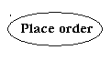
Fig 4.3.2: Use Cases

Third, a node is a physical element that exists at runtime and represents a computational resource, generally having at least some memory and often processing capability.
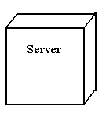
Fig 4.3.3 : Nodes

Behavioral things : Are the dynamic parts of UML models. The behavioral thing used is:
Interaction:
An interaction is a behavior that comprises a set of messages exchanged among a set of objects within a particular context to accomplish a specific purpose. An interaction involves a number of other elements, including messages, action sequences
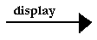
Fig 4.3.4 : Messages

Relationships in the UML:
There are four kinds of relationships in the UML:
- Dependency
- Association
- Generalization
- Realization
A dependency is a semantic relationship between two things in which a change to one thing may affect the semantics of the other thing (the dependent thing).
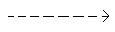
Fig 4.3.5 : Dependencies

An association is a structural relationship that describes a set links, a link being a connection among objects. Aggregation is a special kind of association, representing a structural relationship between a whole and its parts.
Fig4.3.6 : Association

A generalization is a specialization/ generalization relationship in which objects of the specialized element (the child) are substitutable for objects of the generalized element(the parent).
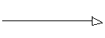
Fig4.3.7 : Generalization

A realization is a semantic relationship between classifiers, where in one classifier specifies a contract that another classifier guarantees to carry out.
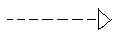
Fig4.3.8 : Realization

Sequence Diagrams
UML sequence diagrams are used to represent the flow of messages, events and actions between the objects or components of a system. Time is represented in the vertical direction showing the sequence of interactions of the header elements, which are displayed horizontally at the top of the diagram.
Sequence Diagrams are used primarily to design, document and validate the architecture, interfaces and logic of the system by describing the sequence of actions that need to be performed to complete a task or scenario. UML sequence diagrams are useful design tools because they provide a dynamic view of the system behavior which can be difficult to extract from static diagrams or specifications.

Actor : Represents an external person or entity that interacts with the system
Fig 4.3.9

Object : Represents an object in the system or one of its components
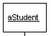
Fig 4.3.10

Unit : Represents a subsystem, component, unit, or other logical entity in the system (may or may not be implemented by objects)
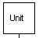
Fig 4.3.11
Separator : Represents an interface or boundary between subsystems, components or units
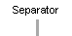
Fig 4.3.11
Group : Groups related header elements into subsystems or components
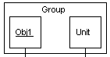
Fig 4.3.12

Sequence Diagram Body Elements
Action : Represents an action taken by an actor, object or unit
Fig 4.3.13
Asynchronous Message : An asynchronous message between header elements

Fig 4.3.14
Block : A block representing a loop or conditional for a particular header element
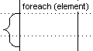
Fig 4.3.15
Call Message : A call (procedure) message between header element

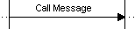

Fig 4.3.16
Create Message : A "create" message that creates a header element (represented by lifeline going from dashed to solid pattern
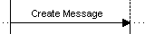
Fig 4.3.17
Diagram Link : Represents a portion of a diagram being treated as a functional block. Similar to a procedure or function call that abstracts functionality or details not shown at this level. Can optionally be linked to another diagram for elaboration.

Fig 4.3.18
Else Block Represents an "else" block portion of a diagram block
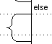
Fig 4.3.19

Message : A simple message between header elements
Fig 4.3.20
Return Message : A return message between header elements
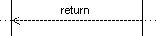
Fig 4.3.21
Sequence diagram for setting security codes.
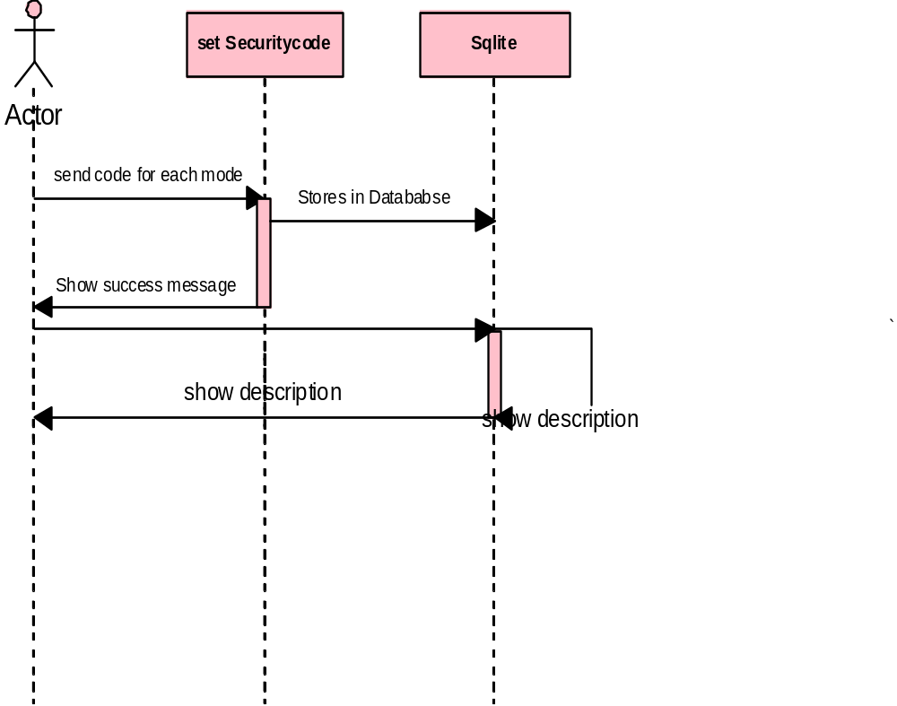

Fig: 4.1

Sequence diagram for changing mode

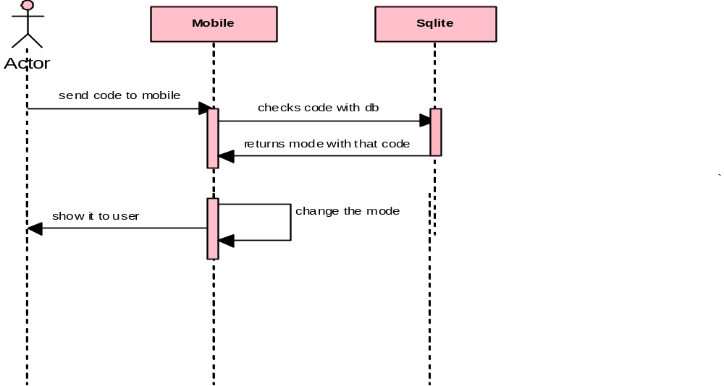
Fig : 4.2

Use Case Diagram
A use case diagram is a graph of actors set of use cases enclosed by a system boundary, communication associations between the actors and users and generalization among use cases. The use case model defines the outside(actors) and inside(use case) of the system’s behavior.
Use case diagram is quite simple in nature and depicts two types of elements: one representing the business roles and the other representing the business processes.
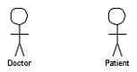
Figure 1: an actor in a use case diagram
To identify an actor, search in the problem statement for business terms that portray roles in the system. For example, in the statement "patients visit the doctor in the clinic for medical tests," "doctor" and "patients" are the business roles and can be easily identified as actors in the system.

Use case : A use case in a use case diagram is a visual representation of a distinct business functionality in a system. The key term here is "distinct business functionality." To choose a business process as a likely candidate for modeling as a use case, you need to ensure that the business process is discrete in nature.

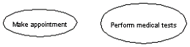
Figure 2: use cases in a use case diagram

USE CASE DIAGRAM 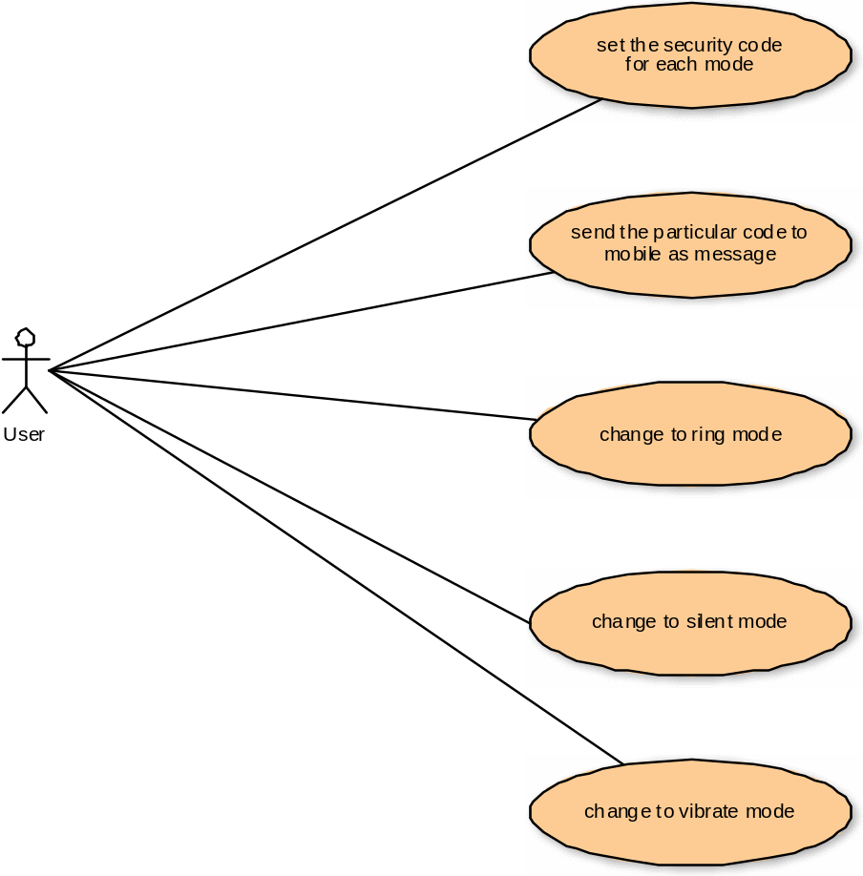

Activity Diagram
Activity diagrams represent the business and operational workflows of a system. An Activity diagram is a dynamic diagram that shows the activity and the event that causes the object to be in the particular state.
So, what is the importance of an Activity diagram, as opposed to a State diagram? A State diagram shows the different states an object is in during the lifecycle of its existence in the system, and the transitions in the states of the objects. These transitions depict the activities causing these transitions, shown by arrows.
An Activity diagram talks more about these transitions and activities causing the changes in the object states.

Elements of an Activity diagram
An Activity diagram consists of the following behavioral elements:

Initial Activity: This shows the starting point or first activity of the flow. Denoted by a solid circle. This is similar to the notation used for Initial State.

Fig 3
Activity: Represented by a rectangle with rounded (almost oval) edges.
.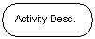
Fig 4
Decisions: Similar to flowcharts, a logic where a decision is to be made is depicted by a diamond, with the options written on either sides of the arrows emerging from the diamond, within box brackets.
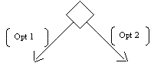
Fig 5

Signal: When an activity sends or receives a message, that activity is called a signal. Signals are of two types: Input signal (Message receiving activity) shown by a concave polygon and Output signal (Message sending activity) shown by a convex polygon.
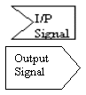
Fig 6

Concurrent Activities: Some activities occur simultaneously or in parallel. Such activities are called concurrent activities. For example, listening to the lecturer and looking at the blackboard is a parallel activity. This is represented by a horizontal split (thick dark line) and the two concurrent activities next to each other, and the horizontal line again to show the end of the parallel activity.
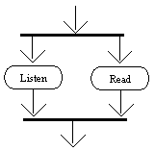
Fig 7

Final Activity: The end of the Activity diagram is shown by a bull's eye symbol, also called as a final activity.

Fig 8

Class Diagram : An object is any person, place, thing, concept, event, screen, or report applicable to your system. Objects both know things and they do things.
A class is a representation of an object and, in many ways, it is simply a template from which objects are created. Classes form the main building blocks of an object-oriented application. Although thousands of students attend the university, you would only model one class, called Student, which would represent the entire collection of students.
Responsibilities : Classes are typically modeled as rectangles with three sections: the top section for the name of the class, the middle section for the attributes of the class, and the bottom section for the methods of the class. Attributes are the information stored about an object, while methods are the things an object or class do. For example, students have student numbers, names, addresses, and phone numbers. Those are all examples of the attributes of a student. Students also enroll in courses, drop courses, and request transcripts. Those are all examples of the things a student does, which get implemented (coded) as methods. You should think of methods as the object-oriented equivalent of functions and procedures.
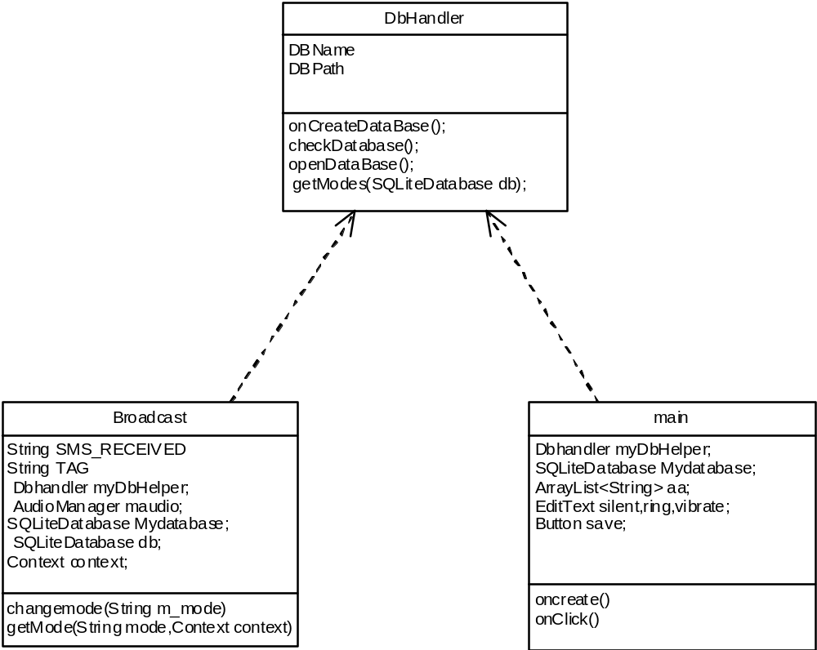

Fig 4.4

Object diagram : An object diagram in the Unified Modeling Language (UML), is a diagram that shows a complete or partial view of the structure of a modeled system at a specific time.
An Object diagram for particular set of object instances and attributes, and the links between the instances. A correlated set of object diagrams provides insight into how an arbitrary view of a system is expected to evolve over time. Object diagrams are more concrete than class diagrams, and are often used to provide examples, or act as test cases for the class diagrams. Only those aspects of a model that are of current interest need be shown on an object diagram.

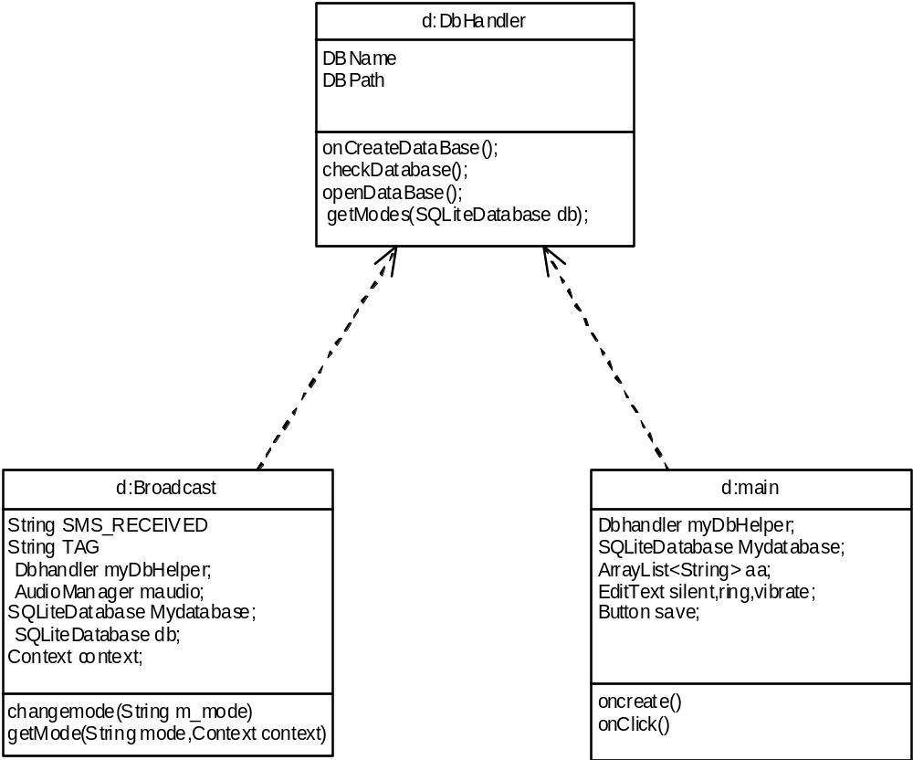

Fig 4.5

State chart diagram :
State chart diagram is used to describe the states of different objects in its life cycle. So the emphasis is given on the state changes upon some internal or external events. These states of objects are important to analyze and implement them accurately.State chart diagrams are very important for describing the states. States can be identified as the condition of objects when a particular event occurs.
Before drawing a State chart diagram we must have clarified the following points:
- Identify important objects to be analyzed.
- Identify the states.
- Identify the events.
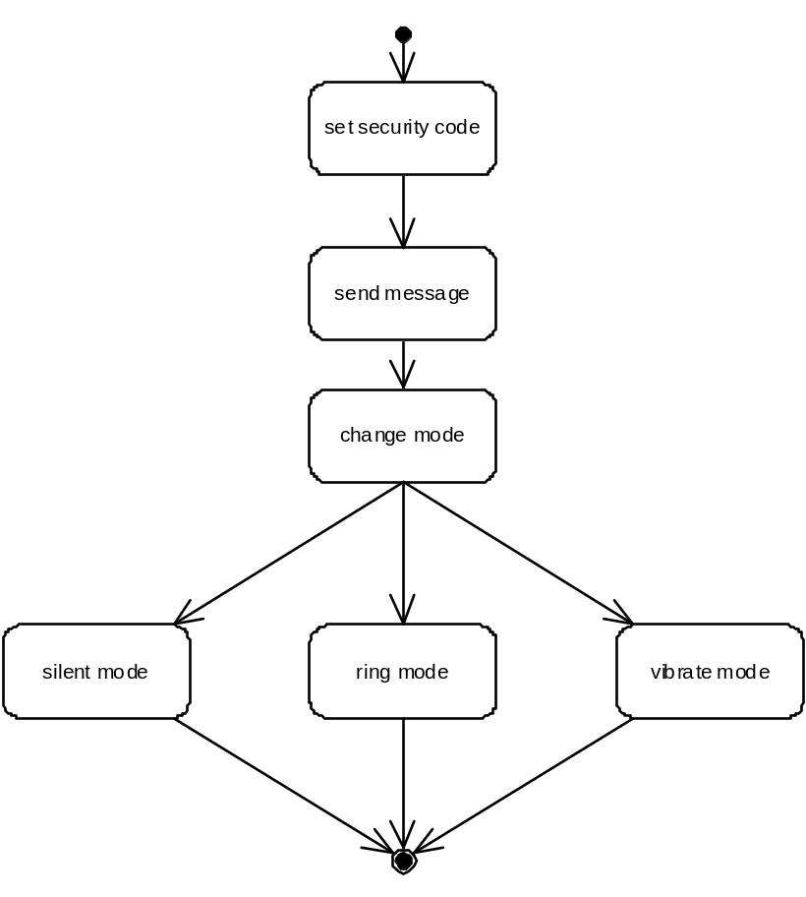
Fig 4.6

Deployment Diagram :

Deployment diagrams are used to visualize the topology of the physical components of a system where the software components are deployed. So deployment diagrams are used to describe the static deployment view of a system. Deployment diagrams consist of nodes and their relationships.
The purpose of deployment diagrams can be described as:
The name Deployment itself describes the purpose of the diagram. Deployment diagrams are used for describing the hardware components where software components are deployed.
- Visualize hardware topology of a system.
- Describe the hardware components used to deploy software components.
- Describe runtime 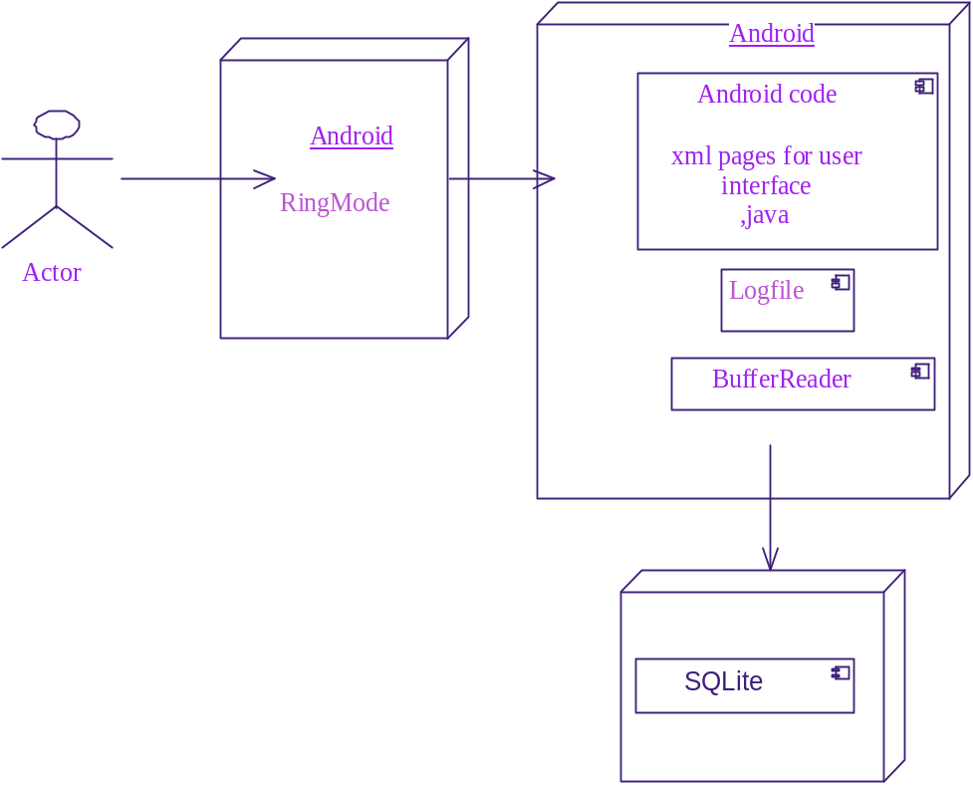 Fig 4.7

5. SYSTEM CODING & IMPLEMENTATION
5.1 Implementation

Implementation literally means to put into effect or to carry out. The system implementation phase of the software deals with the translation of the design specifications into the source code. The ultimate goal of the implementation is to write the source code and the internal documentation so that it can be verified easily. The code and documentation should be written in a manner that eases debugging, testing and modification. System flowcharts, sample run on packages, sample output etc. Is part of the implementation?
An effort was made to satisfy the following goals in order specified.
• Minimization of Response Time.
• Clarity and Simplicity of the Code.
• Minimization of Hard-Coding.

5.2 Coding

SplashUI.java :

package com.mode;
import android.app.Activity;
import android.content.Intent;
import android.os.Bundle;
import android.view.View;
import android.view.ViewGroup;

public class SplashUI extends Activity {
/** Called when the activity is first created. */
@Override
public void onCreate(Bundle savedInstanceState) {
super.onCreate(savedInstanceState);
setContentView(R.layout.firstsplash);
Thread runnerlog=new Thread()
{
public void run()
{
try
{
int logoTimer=0;
while(logoTimer<2000)
{
sleep(100);
logoTimer=logoTimer+100;
}
//startActivity(new Intent("com.mode.HowTo"));
Intent i=new Intent(SplashUI.this,HowTo.class);
startActivity(i);

}catch (Exception e) {
// TODO: handle exception
e.printStackTrace();
}finally
{
finish();
}
}

};

runnerlog.start();
}
@Override
protected void onDestroy() {
// TODO Auto-generated method stub
super.onDestroy();
unbindDrawables(findViewById(R.id.lll));
System.gc();
}

private void unbindDrawables(View view) {
if (view.getBackground() != null) {
view.getBackground().setCallback(null);
}
if (view instanceof ViewGroup) {
for (int i = 0; i < ((ViewGroup) view).getChildCount(); i++) {
unbindDrawables(((ViewGroup) view).getChildAt(i));
}
((ViewGroup) view).removeAllViews();
}
}
}

HowTo.java :

package com.mode;
import android.app.Activity;
import android.content.Intent;
import android.os.Bundle;
import android.view.View;
import android.view.View.OnClickListener;
import android.view.Window;
import android.widget.Button;

public class HowTo extends Activity {
public void onCreate(Bundle savedInstanceState) {
super.onCreate(savedInstanceState);
//requestWindowFeature(Window.FEATURE_CUSTOM_TITLE);
setContentView(R.layout.howto);
Button b=(Button)findViewById(R.id.startb);
b.setOnClickListener(new OnClickListener() {

@Override
public void onClick(View v) {
// TODO Auto-generated method stub
Intent it=new Intent(HowTo.this,main.class);
startActivity(it);
}
});
}
}

Main.java

package com.mode;
import java.io.IOException;
import java.util.ArrayList;

import android.app.Activity;
import android.content.Context;
import android.database.SQLException;
import android.database.sqlite.SQLiteDatabase;
import android.os.Bundle;
import android.view.View;
import android.view.View.OnClickListener;
import android.widget.Button;
import android.widget.EditText;
import android.widget.Toast;

public class main extends Activity {
Dbhandler myDbHelper;
SQLiteDatabase Mydatabase;
ArrayList<String> aa;
EditText silent,ring,vibrate;
Button save;

/** Called when the activity is first created. */
@Override
public void onCreate(Bundle savedInstanceState) {
super.onCreate(savedInstanceState);
setContentView(R.layout.main);
silent=(EditText)findViewById(R.id.silent);
ring=(EditText)findViewById(R.id.ring);
vibrate=(EditText)findViewById(R.id.vibrate);
save=(Button)findViewById(R.id.Save);
this.myDbHelper=new Dbhandler(this);
FetchingData();
Mydatabase=myDbHelper.getReadableDatabase();
aa=this.myDbHelper.getModes(Mydatabase);
System.out.println("values of Db "+aa);
String s1= aa.toString();
s1=s1.substring(1, s1.length()-1);
//s1=s1.replace("", newChar)
String[] s=s1.split(",");

silent.setText(s[0]);
ring.setText(s[1]);
vibrate.setText(s[2]);
save.setOnClickListener(new OnClickListener(){
@Override
public void onClick(View arg0) {
// TODO Auto-generated method stub
String stxt=silent.getText().toString();
String rtxt=ring.getText().toString();
String vtxt=vibrate.getText().toString();
if(stxt.equals("") || rtxt.equals("") || vtxt.equals(""))
{
Toast.makeText(getApplicationContext(), "Please fill all fields", 60).show(); }
else
{
/*Context context = getApplicationContext();
CharSequence error = "Please enter a track name" +stxt;
int duration = Toast.LENGTH_LONG;
Toast toast = Toast.makeText(context, error, duration);
toast.show();*/
myDbHelper=new Dbhandler(main.this);
FetchingData();
Mydatabase=myDbHelper.getReadableDatabase();
Mydatabase.execSQL("update mode set text='"+stxt+"' where Mode='silent'");
System.out.println("^^^^^^^^^^^^^^^ inserted value is "+stxt);
Mydatabase.execSQL("update mode set text='"+rtxt+"' where Mode='ring'");
Mydatabase.execSQL("update mode set text='"+vtxt+"' where Mode='vibrate'");
Toast.makeText(getApplicationContext(), stxt, 70).show();
}

}
});
}
private void FetchingData() {

// TODO Auto-generated method stub
try {

myDbHelper.onCreateDataBase();

} catch (IOException ioe) {

throw new Error("Unable to create database");

}
try {

myDbHelper.openDataBase();
Mydatabase = myDbHelper.getWritableDatabase();
System.out.println("executed");

}catch(SQLException sqle){

throw sqle;

}
// TODO Auto-generated method stub

}
]

5.3 Screen Shots

START UP SCREEN

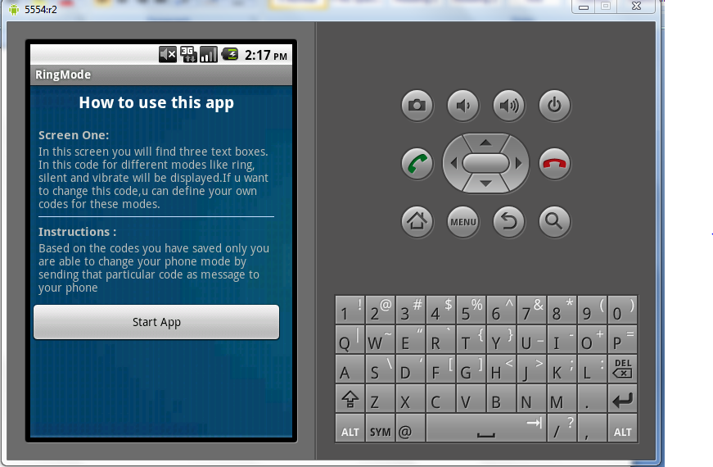

Fig 5.3.1

CODE SCREEN

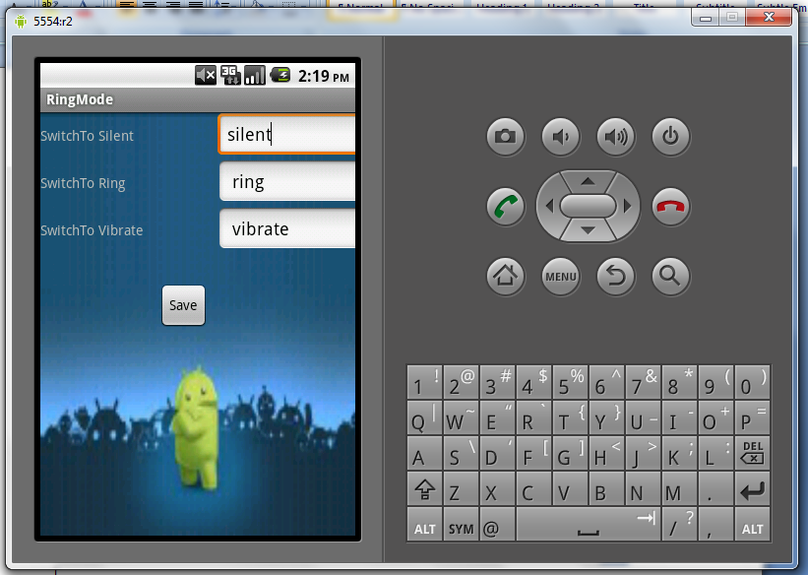

Fig 5.32

TESTING AND VALIDATION

6. TESTING AND VALIDATION
The development of software systems involves of a series of production activities where opportunities for injection of human fallibilities are enormous. Errors may begin to occur at the very inception of the process where the objectives may be erroneously or imperfectly specified, as well as in later design and development stages. Because of human inability to perform and communicate with perfection, software development is accompanied by a quality assurance activity.
TESTING TECHNIQUES
Testing is the process of executing a program with the intention of finding errors. The various test strategies used for testing the software are as follows
6.1 Unit Testing
Unit testing focuses on verification effort on the smallest unit of the software design module. The main goal is to make sure that every source statement and logic path has been executed correctly at least once. The output of this stage is the source code.
6.2 Integration Testing
In Integration testing, we find errors that have occurred during the integration. After testing each module, which is then integrated into subsystems and then to form the entire system on which integration testing is performed. The goal of testing is to detect the design errors, while focusing on the testing the interconnection between modules.

6.3 Validation Testing
This testing concentrates on confirming that the software is error-free in all respects. All the specified validations are verified and the software is subjected to hard-core testing. It also aims at determining the degree of deviation that exists in the software designed from the specification; they are listed out and are corrected.
6.4 System Testing
In this testing, the system is tested for the errors after coupling all the modules together The system is tested against the specified requirements to see if all the requirements are met and the system performs as specified by the requirements.
7. CONCLUSION AND FUTURE ENHANCEMENTS

7.1 Conclusion
This application is used for changing phone mode. This application is build in Google mobiles using Android SDK. It is a tool developed for android platform, which is used to search various books and their related information within the mobile. This is an advantage when compared to existing system because a single mobile piece is enough for deploying the application .As this is a mobile application one can easily search for required information. One can search for books whenever one wants to without waiting for some system. This makes this application efficient, convenient and easy to use along with providing maximum user satisfaction which is the key aspect for any developer.

7.2 Future Enhancements
The GPS tracker is the future enhancement for the project “ Profile Swapper “ for the android mobiles. The GPS tracker has the functionality to trace the mobile where ever it is located. It traces the location of the mobile. This can happen only with the internet connectivity.
8. REFERENCES

- Herbert Schildt.2008 ,”Java Complete Reference”, Tata McGraw-Hill , 7th Edition, pp.177-180 .
- Grady Booch, James Rambaugh.1998,“UnifiedModeling Language User Guide”, Addison Wesley Publishing, chapter 8-31.
- http://developer.android.com/guide/index.html
- http://en.wikipedia.org/wiki/SQLite
- http://developer.android.com/reference/packages.html
- http://developer.android.com/guide/topics/ui/declaring-layout.html
- http://developer.android.com/resources/samples/get.html
- http://groups.google.com/group/android-developers?lnk=

